Comp2147- Lab10
Name: Garv, Student ID: 101566625

- Dialogue Design
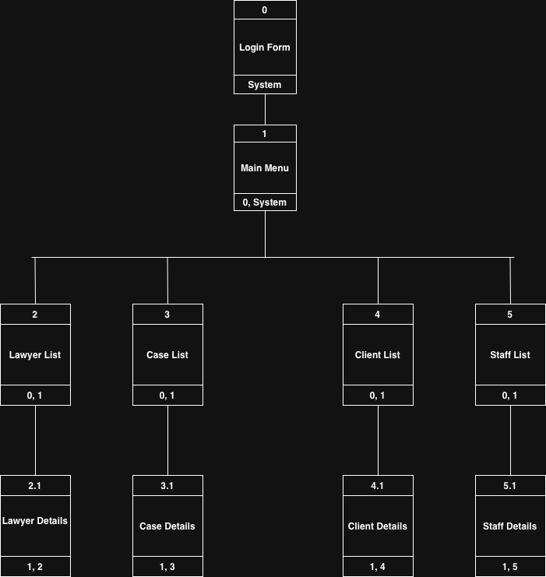

- Wireframes

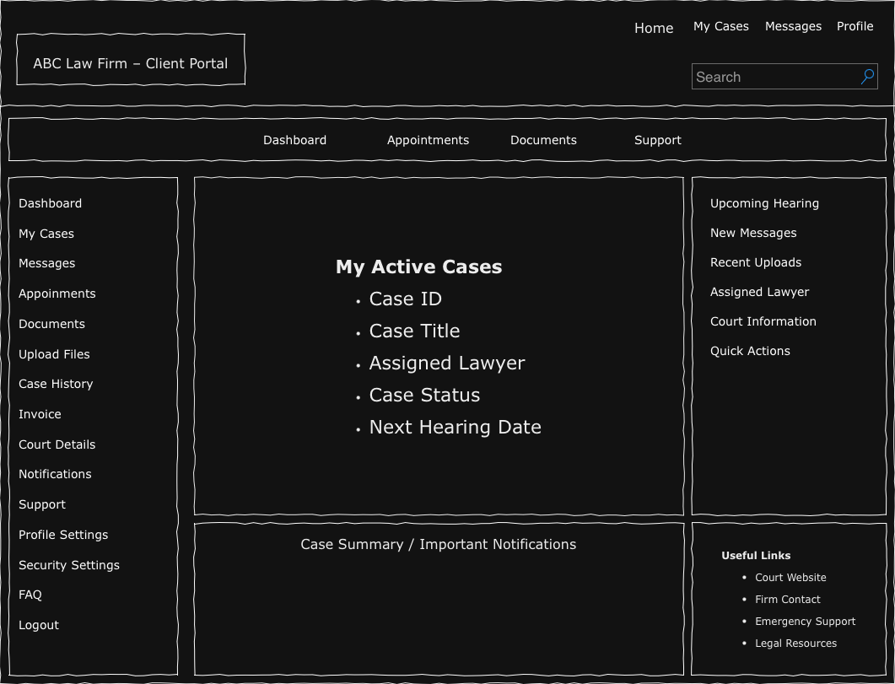

Thank-You Professor…..

